**Federated Learning & Data Privacy, 2024-2025**

**Nguyen Dinh Huy**

**Third Lab - 11 February 2025**

Welcome to the third lab session of the Federated Learning & Data Privacy course! Today we will see how to implement Federated Learning in real network systems.

1. **EXERCISE 5 - Federated Learning with Flower**

**Objective**: Gain practical experience with the [Flower federated learning framework](https://flower.ai/docs/framework/index.html) by deploying a real, distributed federated learning experiment. Explore personalized federated learning algorithms and compare their performance against the standard FedAvg.

1. **EXERCISE 5.1 - Federated Learning on Real Networks**

**Goal**: Deploy a federated learning system using PyTorch and Flower to understand the setup and execution of federated learning in a networked environment.

**Setup**

1. **Clone the Flower repository and set up the PyTorch quickstart example**:

git clone --depth=1 https://github.com/adap/flower.git && mv flower/examples/quickstart-pytorch . && rm -rf flower && cd quickstart-pytorch

1. **Install the dependencies**:

pip install -e .

**Run Federated Learning**

* **Launch the simulation**

flwr run .

* Observe the federated training process initiated by PyTorch through Flower.

You can find complete instructions [here](https://github.com/adap/flower/tree/main/examples/quickstart-pytorch).

1. **EXERCISE 5.2 - Tackling Data Heterogeneity with FedProx**

**Objective**: Understand how the FedProx algorithm addresses the challenges posed by data heterogeneity in federated learning and compare its performance with the FedAvg algorithm.

* **FedProx Overview**: FedProx modifies the local training objective by introducing a proximal term, which aims to reduce local model drift by penalizing significant deviations from the global model. Review the FedProx algorithm [Federated Optimization in Heterogeneous Networks (Algorithm 2)](https://arxiv.org/abs/1812.06127).
* **Instructions**: Follow the tutorial on FedProx available at [Flower's documentation](https://flower.ai/docs/baselines/fedprox.html). Run experiments trying different number of rounds and different mu values.
* **Analysis**: Discuss the observed differences in performance between FedAvg and FedProx. Are there specific configurations (e.g., number of local epochs) where FedProx particularly outperforms FedAvg?

**RESULT :**

**Code Link** [**: https://github.com/DinhHuy1405/Federated-Learning-2024---2025/tree/main/TP3**](https://github.com/DinhHuy1405/Federated-Learning-2024---2025/tree/main/TP3)

**Observations from the Experiment**

The graph shows validation accuracy over **100 rounds** for three federated learning approaches:

1. **FedAvg (μ = 0)** → Traditional federated averaging.
2. **FedProx (μ = 2)** → FedProx with a strong regularization term.
3. **FedProx (μ = 0)** → Equivalent to FedAvg.

**Key Insights:**

**1. FedAvg (μ = 0) vs. FedProx (μ = 0):**

* As expected, **FedAvg (μ = 0)** and **FedProx (μ = 0)** behave similarly because FedProx with μ = 0 is equivalent to FedAvg.
* There are slight performance variations, but both approaches show almost identical trends in accuracy improvement over time.
* Any small differences could be attributed to implementation details or stochastic effects.

**2. FedAvg (μ = 0) vs. FedProx (μ = 2):**

* **FedAvg (μ = 0)** achieves significantly **higher accuracy** over time compared to **FedProx (μ = 2)**.
* **FedProx (μ = 2) starts with a similar accuracy but converges much more slowly**.
* This suggests that a strong proximal term (μ = 2) effectively **reduces client drift** but also **restricts adaptation**, leading to **lower overall accuracy**.

**3. FedProx (μ = 2) vs. FedProx (μ = 0):**

* **FedProx (μ = 0) consistently outperforms FedProx (μ = 2)**.
* This indicates that for this dataset and training setup, a **strong proximal constraint (μ = 2) overly restricts local model updates**, preventing optimal learning.

**Analysis of Data Heterogeneity**

* **FedProx** is designed to mitigate **data heterogeneity** by limiting client model divergence.
* However, selecting an appropriate **μ** value is critical:
  + **Small μ (close to 0)**: Allows more flexibility but may suffer from client drift.
  + **Large μ** : Reduces drift but slows down convergence, leading to suboptimal performance.

**Impact of Local Epochs**

* The impact of FedProx **may vary depending on the number of local epochs**:
  + **If local training lasts multiple epochs**, FedAvg may diverge more due to heterogeneous data distributions.
  + **FedProx can help by constraining local updates**, keeping them closer to the global model.
  + **In scenarios with higher local epochs, FedProx might perform better** than FedAvg.

1. **BONUS EXERCISE - Personalized Federated Learning**

**Goal**: Evaluate a personalized federated learning algorithm using Flower, showing its possible advantages over the FedAvg algorithm.

**Choose one of the two proposed personalization algorithms:**

1. **Federated Learning with Personalization Layers (FedPer)**
   * **Overview**: FedPer implements personalization by allowing some neural network layers to be client-specific, making the model closer to individual data distributions.
   * **Instructions**: Follow the tutorial on FedPer available at [Flower's documentation](https://flower.ai/docs/baselines/fedper.html).

**Evaluation**

* Reproduce the tutorial and compare the results with FedAvg to highlight the benefits of personalization.

**RESULT:**

**Code Link:** [**https://github.com/DinhHuy1405/Federated-Learning-2024---2025/tree/main/TP3**](https://github.com/DinhHuy1405/Federated-Learning-2024---2025/tree/main/TP3)

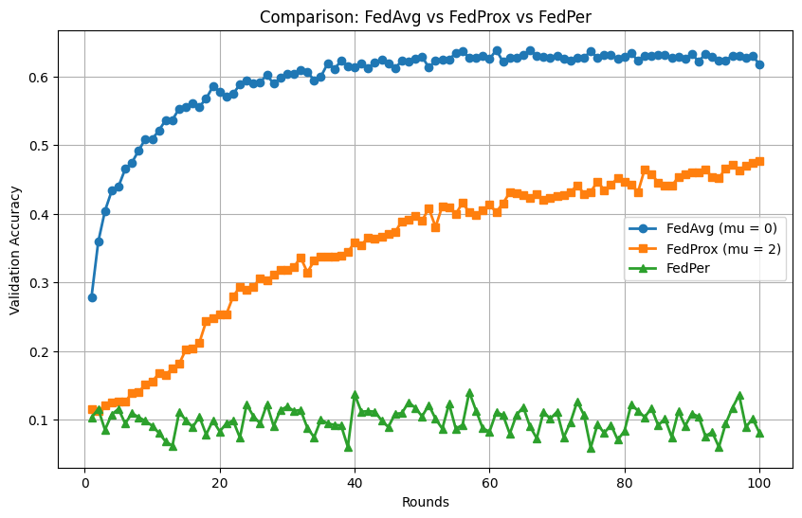

**Observations from the Experiment**

The graph displays the validation accuracy over **100 rounds** for three federated learning strategies:

1. **FedAvg (μ = 0)** → Traditional federated averaging.
2. **FedProx (μ = 2)** → FedProx with a strong regularization term.
3. **FedPer** → An approach focusing on personalized federated learning.

**Key Insights:**

**1. FedAvg (μ = 0):**

* **FedAvg (μ = 0)** shows the highest and most stable performance, achieving over **60% accuracy**.
* It is the most effective strategy among the three, displaying rapid and consistent improvements in accuracy.

**2. FedProx (μ = 2):**

* **FedProx (μ = 2)** starts with lower accuracy but gradually improves, stabilizing around **40% accuracy**.
* The strong regularization parameter (μ = 2) seems to limit performance initially but ensures moderate improvements over time.

**3. FedPer:**

* **FedPer**, aiming at personalized models, shows much lower and fluctuating performance, with accuracy hovering around **10%**.
* This suggests potential issues in personalization effectiveness or instability in the learning process under this specific setup.

**Comparison and Analysis:**

* **FedAvg (μ = 0) vs. FedProx (μ = 2):**
  + As seen before, **FedAvg** consistently outperforms **FedProx with a strong μ**. The lack of a regularization constraint allows for more adaptable but possibly more varied client updates.
  + **FedProx** reduces client drift but at a significant cost to convergence speed and ultimate performance.
* **FedAvg (μ = 0) vs. FedPer:**
  + **FedAvg** significantly outperforms **FedPer**, indicating that the non-personalized model is more effective in this scenario.
  + **FedPer's** performance suggests that its approach to personalization might not be effectively capturing useful patterns or it might be too sensitive to client-specific noise.
* **FedProx (μ = 2) vs. FedPer:**
  + Even with its conservative updates, **FedProx** performs better than **FedPer**, further highlighting the challenges in the personalization strategy employed by **FedPer**.